Advanced Mockito Hands-On Exercises
Exercise 1: Mocking Databases and Repositories You need to test a service that interacts with a database repository.
Steps: 1. Create a mock repository using Mockito.
2. Stub the repository methods to return predefined data.
3. Write a test to verify the service logic using the mocked repository.
Solution Code:
import static org.mockito.Mockito.*;
import org.junit.jupiter.api.Test;
import static org.junit.jupiter.api.Assertions.*;
public class ServiceTest {
@Test public void testServiceWithMockRepository() {
Repository mockRepository = mock(Repository.class); when(mockRepository.getData()).thenReturn("Mock Data");
Service service = new Service(mockRepository);
String result = service.processData();
assertEquals("Processed Mock Data", result);
} }
SOLUTION:
Repository.java:
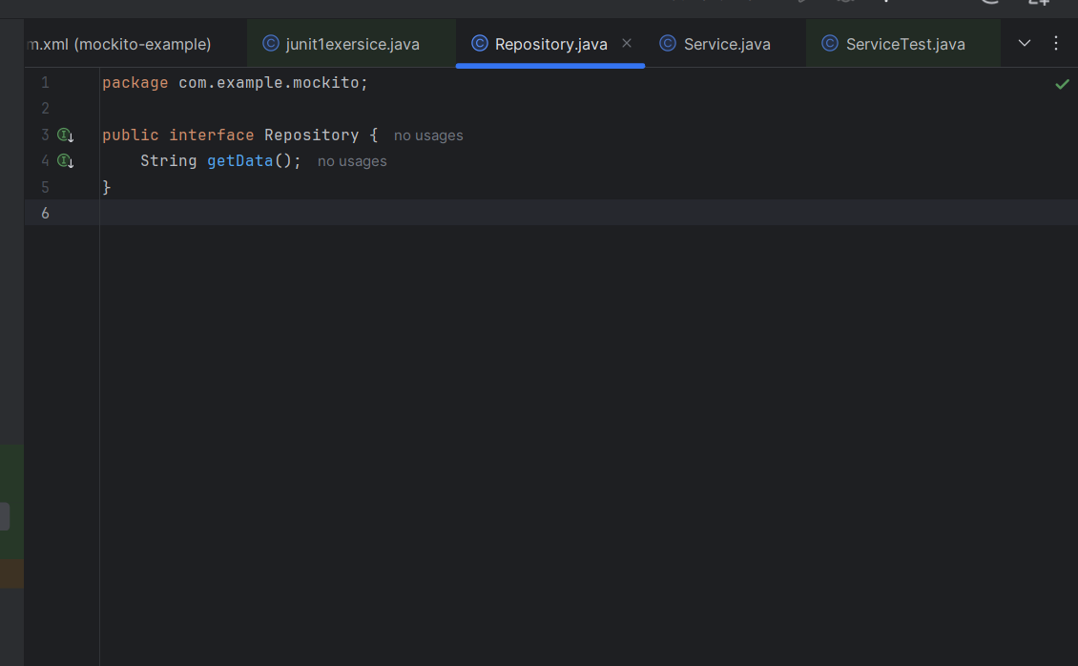
Service.java:
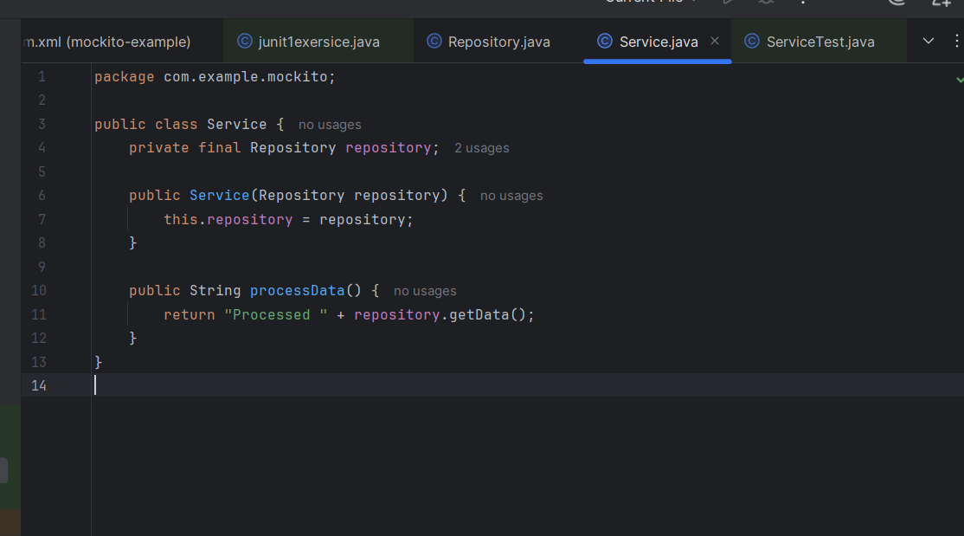
ServiceTest.java:
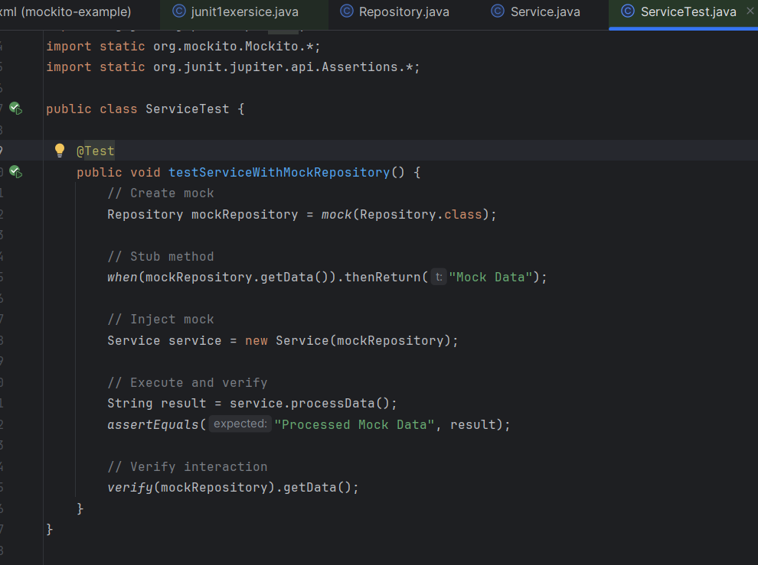
OUTPUT:
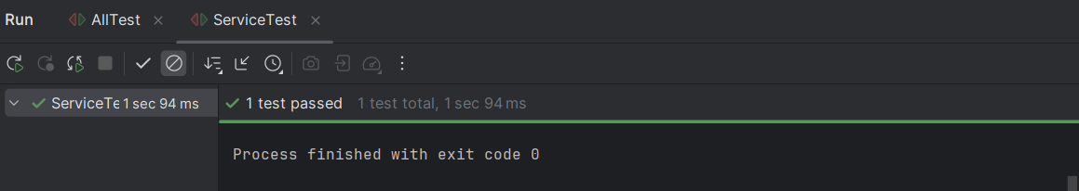

Exercise 2: Mocking External Services (RESTful APIs)
You need to test a service that calls an external RESTful API.
Steps: 1. Create a mock REST client using Mockito.
2. Stub the REST client methods to return predefined responses.
3. Write a test to verify the service logic using the mocked REST client.
Solution Code:
import static org.mockito.Mockito.*;
import org.junit.jupiter.api.Test;
import static org.junit.jupiter.api.Assertions.*;
public class ApiServiceTest {
@Test public void testServiceWithMockRestClient() {
RestClient mockRestClient = mock(RestClient.class); when(mockRestClient.getResponse()).thenReturn("Mock Response");
ApiService apiService = new ApiService(mockRestClient);
String result = apiService.fetchData();
assertEquals("Fetched Mock Response", result);
} }
SOLUTION:
Restlient.java:
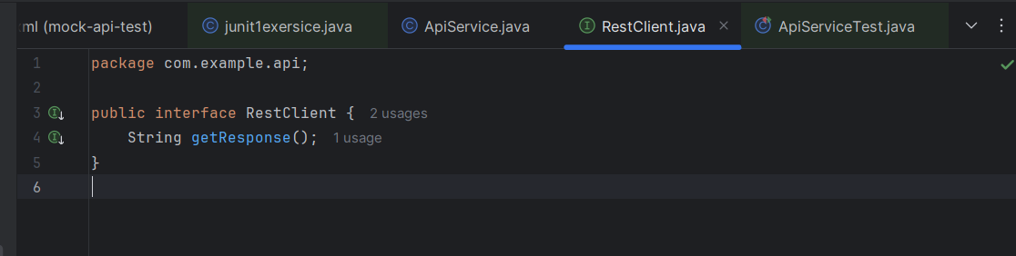
ApiService.java:
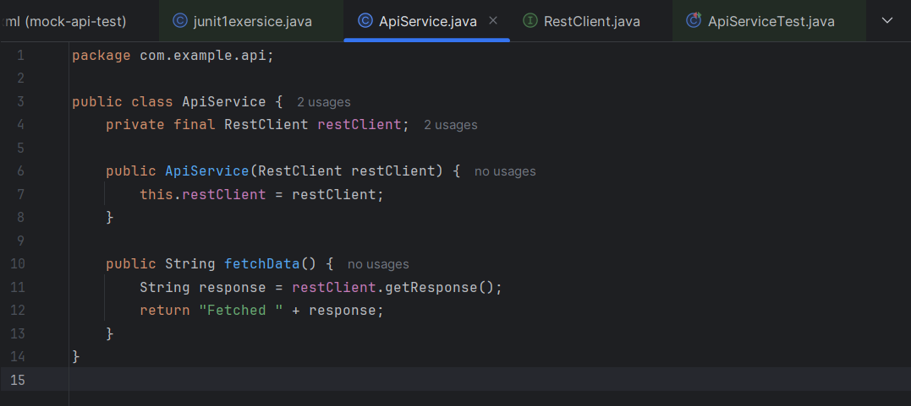
ApiServiceTest.java:
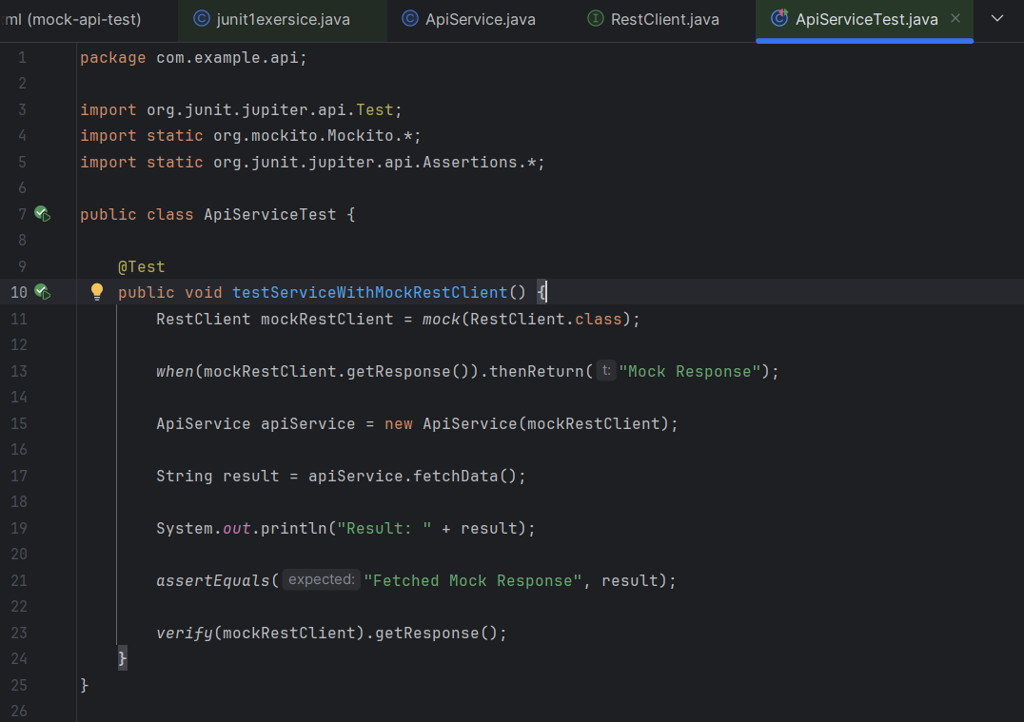
OUTPUT: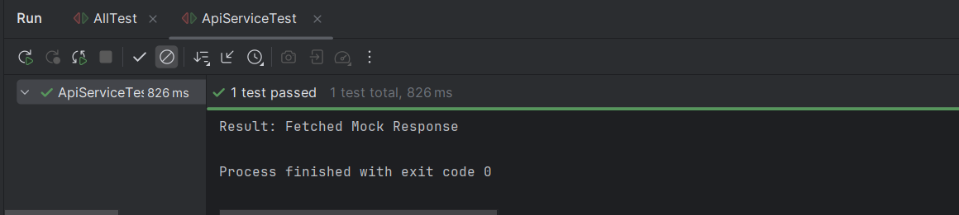
Exercise 3: Mocking File I/O
You need to test a service that reads from and writes to files.
Steps: 1. Create a mock file reader and writer using Mockito.
2. Stub the file reader and writer methods to simulate file operations.
3. Write a test to verify the service logic using the mocked file reader and writer.
Solution Code:
import static org.mockito.Mockito.*;
import org.junit.jupiter.api.Test;
import static org.junit.jupiter.api.Assertions.*;
public class FileServiceTest {
@Test public void testServiceWithMockFileIO() {
FileReader mockFileReader = mock(FileReader.class);
FileWriter mockFileWriter = mock(FileWriter.class); when(mockFileReader.read()).thenReturn("Mock File Content");
FileService fileService = new FileService(mockFileReader, mockFileWriter);
String result = fileService.processFile();
assertEquals("Processed Mock File Content", result);
} }

SOLUTION:

FileReader.java:
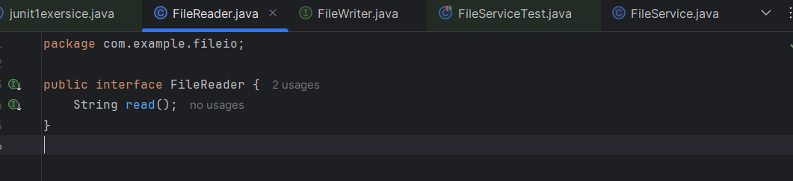

FileWriter.java:
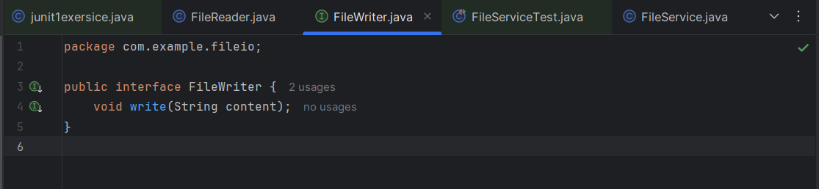
FileService.java:
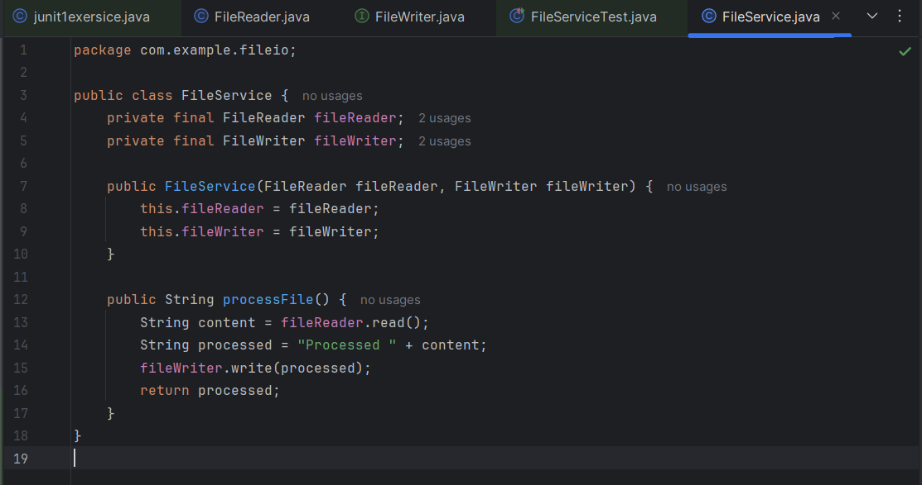

FileServiceTest.java:
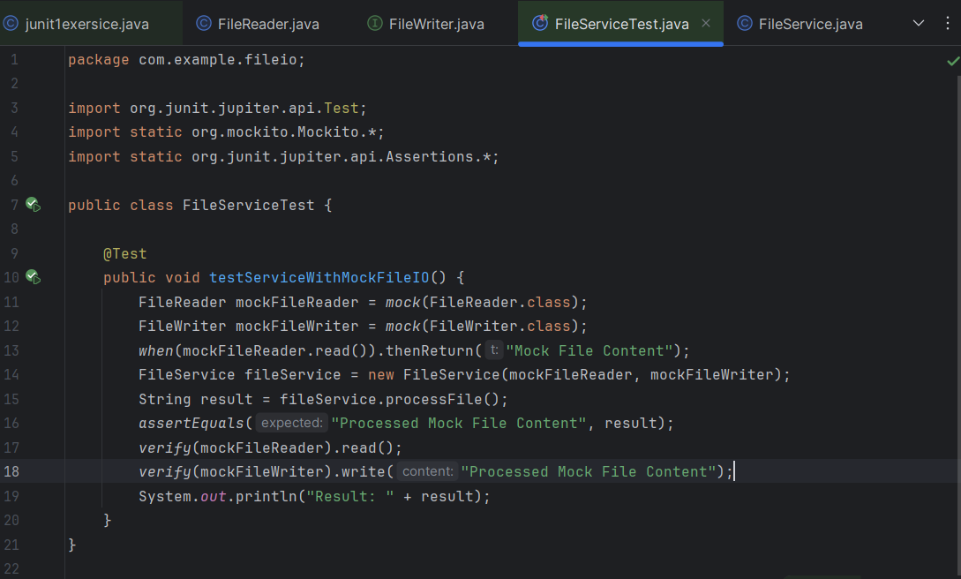
OUTPUT:
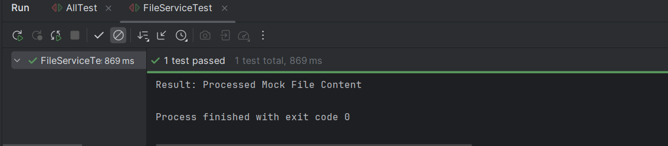

Exercise 4: Mocking Network Interactions You need to test a service that interacts with network resources.
Steps: 4. 1. Create a mock network client using Mockito.
5. 2. Stub the network client methods to simulate network interactions.
6. 3. Write a test to verify the service logic using the mocked network client.
Solution Code:
import static org.mockito.Mockito.*;
import org.junit.jupiter.api.Test;
import static org.junit.jupiter.api.Assertions.*;
public class NetworkServiceTest {
@Test public void testServiceWithMockNetworkClient() {
NetworkClient mockNetworkClient = mock(NetworkClient.class); when(mockNetworkClient.connect()).thenReturn("Mock Connection");
NetworkService networkService = new NetworkService(mockNetworkClient);
String result = networkService.connectToServer();
assertEquals("Connected to Mock Connection", result);
} }
SOLUTION:
NetworkClient.java:
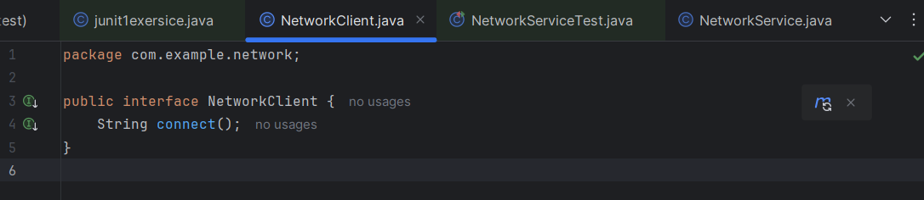

NetworkService.java:
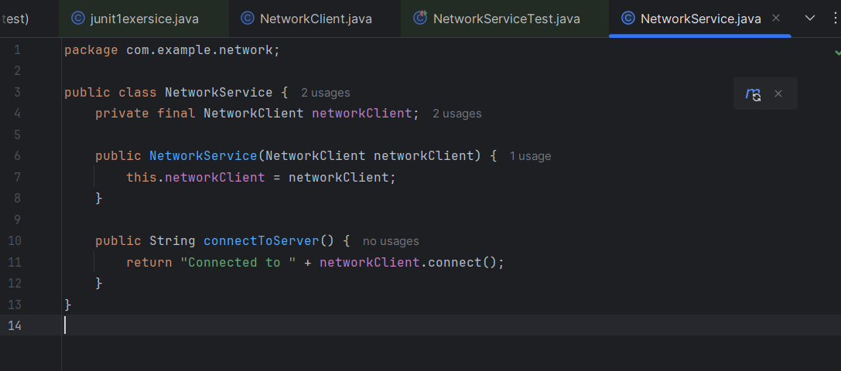
NetworkClientTest.java:
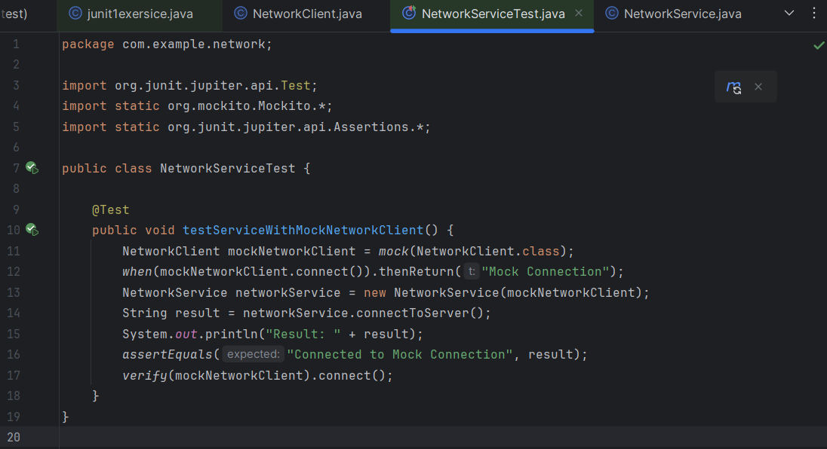
OUTPUT:
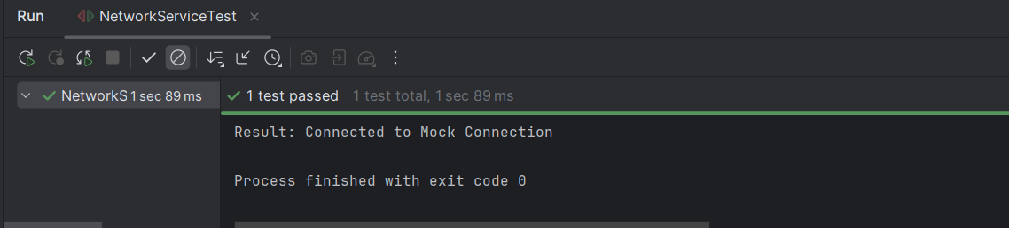
Exercise 5: Mocking Multiple Return Values
You need to test a service that calls a method multiple times with different return values. Steps:
1. Create a mock object using Mockito.
2. Stub the method to return different values on consecutive calls.
3. Write a test to verify the service logic using the mocked object.
Solution Code:
import static org.mockito.Mockito.*;
import org.junit.jupiter.api.Test;
import static org.junit.jupiter.api.Assertions.*;
public class MultiReturnServiceTest {
@Test public void testServiceWithMultipleReturnValues() {
Repository mockRepository = mock(Repository.class);
when(mockRepository.getData()) .thenReturn("First Mock Data") .thenReturn("Second Mock Data");
Service service = new Service(mockRepository);
String firstResult = service.processData();
String secondResult = service.processData();
assertEquals("Processed First Mock Data", firstResult); assertEquals("Processed Second Mock Data", secondResult);
} }
SOLUTION:
Repository.java:
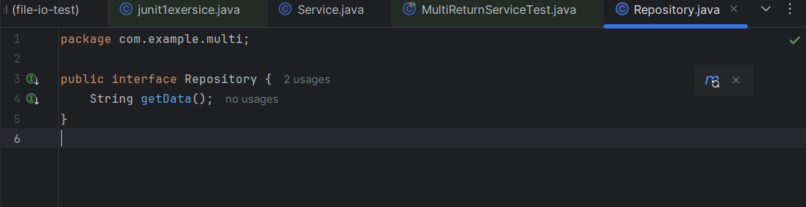

Service.java:
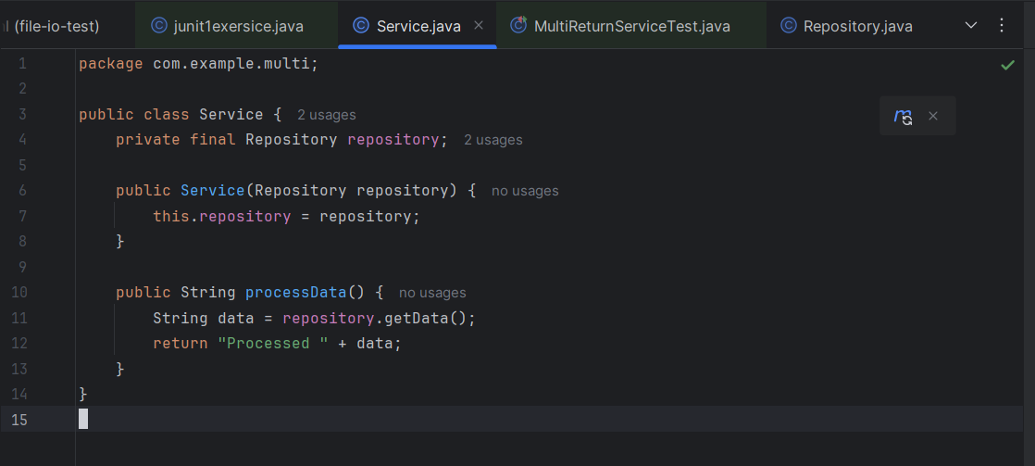
MultiReturnServiceTest.java:
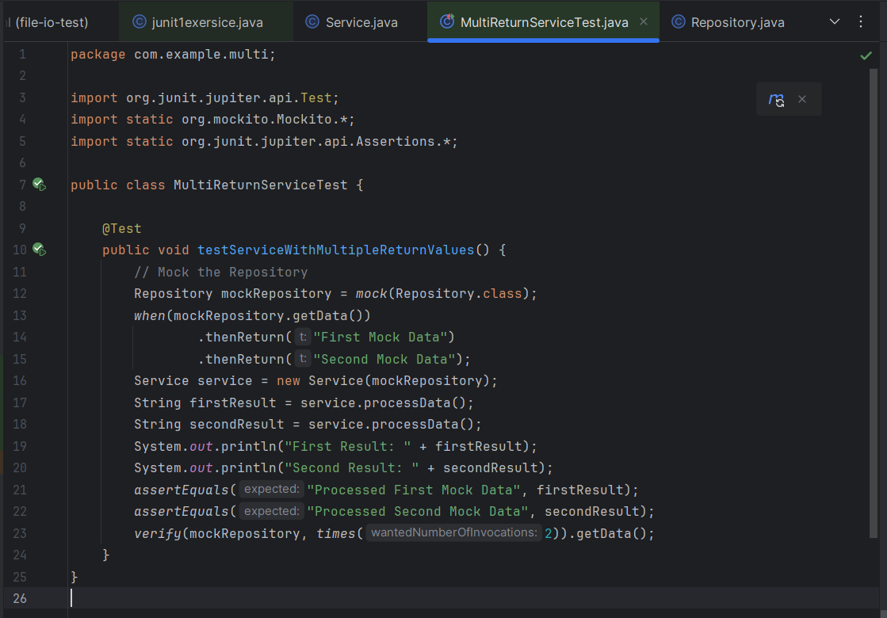
OUTPUT:
